The story of Sister Lalitha Fernando
Sister Lalitha. Copyright: St Francis Leprosy Guild
Badulla is an ancient city in the lower central hills of Sri Lanka. It is a tourist destination and an agricultural area surrounded by mountains and hills. It is also home to a leprosy centre supported by the Order of the Franciscan Missionaries of Mary.
Sister Lalitha Fernando is a Catholic nun who works in this community.
She was born 61 years ago here in Sri Lanka. When she was only 21, she felt called by “a voice from within” to become a nun. She was drawn to the contemplative yet active nature of the Franciscan Missionaries of Mary and to the service of the “the downtrodden.” On learning that St Francis loved people with leprosy, her decision to join this Order of Sisters was made.

Although her days are filled with prayer, her work often takes her to remote locations in the interior of Sri Lanka where people affected by leprosy live lives of subsistence and poverty. She visits around 22 people every month journeying by car, bus, or auto rickshaw often travelling on rough roads for hours on end. She visits people with leprosy as their friend, so their neighbours don’t suspect a link to leprosy, and the stigma and rejection, so often associated with this disease, can be avoided.
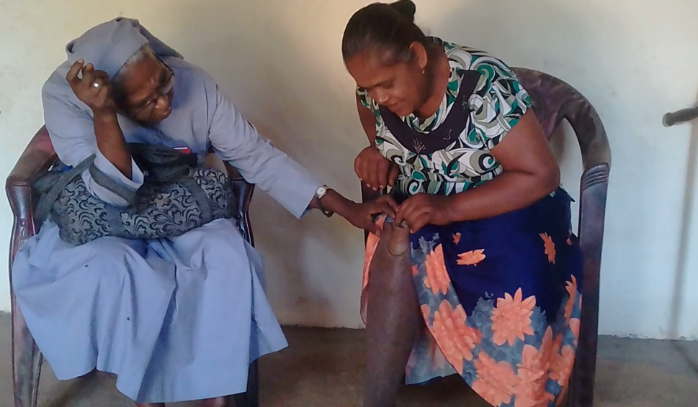
Sister Lalitha visiting a person with leprosy with a suspected leprosy ulcer. Copyright St Francis Leprosy Guild
Sister Lalitha is aware that people with leprosy suffer from weakened immune systems and are susceptible to disease and injury and especially, to developing leprosy-related ulcers. So, she takes medication on her visits as well as provisions, such as milk powder and nutritional supplements to top up their daily rations. People with leprosy live in considerable hardship, even if their community is unaware that they are affected by leprosy. They are grateful for anything she can give them. But Sr Lalitha, gives something more valuable than provisions. People with leprosy can share their situation with her in confidence. In her, they find someone who will listen and care.

“Some of the people that I visit are so elderly and frail, some are isolated and lonely, some suffer from lifelong leprosy disabilities, and some are trying to farm the land to exist.

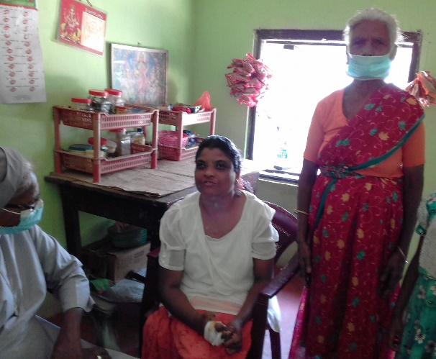
Sister Lalitha visiting Shivalingam, whose legs have been amputated due to leprosy. She is cared for by her mother. Copyright: St Francis Leprosy Guild
“I visit a 40-year-old woman, whose legs are amputated due to leprosy and who is cared for by her 60-year-old mother. I take them provisions and nutritional supplements. When I first met them, their house was dilapidated, and the roof was falling in. Thanks to the generous support of St Francis Leprosy Guild, we have since replaced the ceiling, provided running water and a toilet.”
“I visit a farmer who grows rice. Whenever the rain fails, there will be no rice crop, and the farmer will suffer for a whole year. He might have to work as a labourer to try and make ends meet. We managed to get him a fishing licence, so he is allowed to fish now. Otherwise, it’s very difficult for him to survive.”
I am very grateful that through SFLG I can provide some support for people with leprosy otherwise they would be left on their own to perish. Everyone I visit is very grateful for everything that I can bring, such as medication or provisions. It’s almost impossible for them to survive without support.”
“No matter how long my journey or how tired I feel, I love doing the work of St Francis,” said
Sister Lalitha.”

