PRESS RELEASE
World Leprosy Day 2022
Our Silent Heroes – Catholic Nuns
London, 30 January 2022: On World Leprosy Day 2022, St Francis Leprosy Guild asks the Catholic community to reflect on the great work carried out by the Catholic Orders of nuns and to unite in prayer for God’s blessing on their vocation.
Throughout the world, working in remote or impoverished locations, Catholic nuns, with hearts of compassion and dedication, are caring for people with leprosy, visiting those that are alone or isolated and restoring dignity.
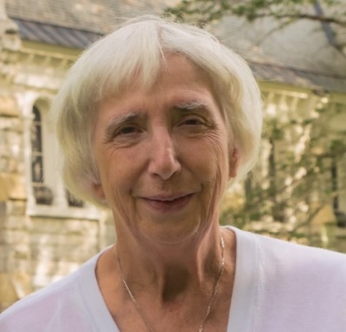
“Effective, compassionate, Christian care is hard to beat. Some nuns devote their entire lives to caring for people with leprosy,” said Dr Gosia Brykczyńska, RN/RSCN, European President of The International Association of Catholic Nurses (SICIAMS) and Trustee of St Francis Leprosy Guild.
Throughout its history and as part of its TRACE operating strategy, St Francis Leprosy Guild has partnered with Catholic Orders: nuns who devote their lives to caring for people affected by leprosy.
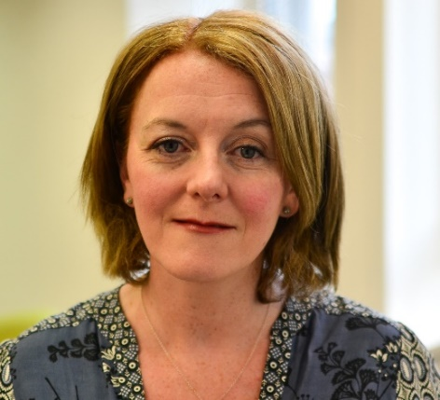
“It is impossible to quantify how much our dedicated Catholic nuns have transformed lives by caring for people with leprosy and dealing with the loneliness and neglect that come from leprosy stigma” said SFLG’s Chief Executive Officer, Clare McIntosh. “Their unspoken legacy of love and dedication is immeasurable and, thank heavens, continues unceasingly. We feel privileged to support the great work of our Silent Heroes.”

Sister Lalitha Fernando of the Franciscan Missionaries of Mary (FMM) works with leprosy patients from the Badulla Leprosy Centre, situated in the lower central hills of Sri Lanka. Her work often includes long journeys, travelling to remote locations. She visits people with leprosy as their friend, so their neighbours don’t suspect a link with leprosy, and the stigma and rejection, so often associated with this disease, can be avoided.
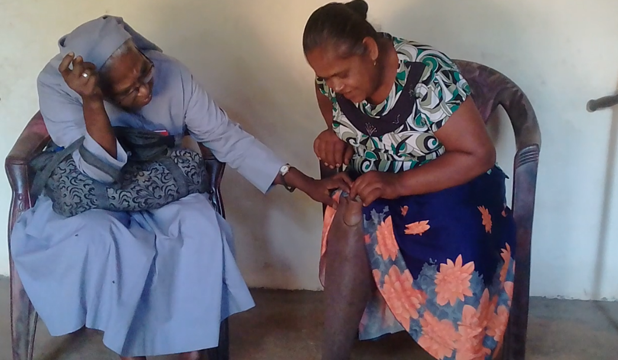
Sr Lalitha visiting a friend affected by leprosy, with a suspect ulcer caused by leprosy.
By kind permission of St Francis Leprosy Guild
“No matter how long my journey or how tired I feel, I love doing the work of St Francis” said Sister Lalitha who visits around 22 people with leprosy every month. Some are frail and elderly, others are isolated and alone, some are living with lifelong disabilities due to leprosy and others are subsistence farmers.
“Whenever the rain fails, there will be no rice crop, and the farmers will suffer that whole year. They may have to work as labourers to supplement their income. Everyone I visit is very grateful for anything that I can bring them, such as medication or provisions. Otherwise, it’s very difficult for them to survive.”
“I visit a 40-year-old woman, whose leg is amputated due to leprosy and who is cared for by her 60-year-old mother. I take them provisions and nutritional supplements. When I first met them, their house was dilapidated, and the roof was falling in. We have since replaced the ceiling, provided running water and a toilet thanks to the support of St Francis Leprosy Guild.”
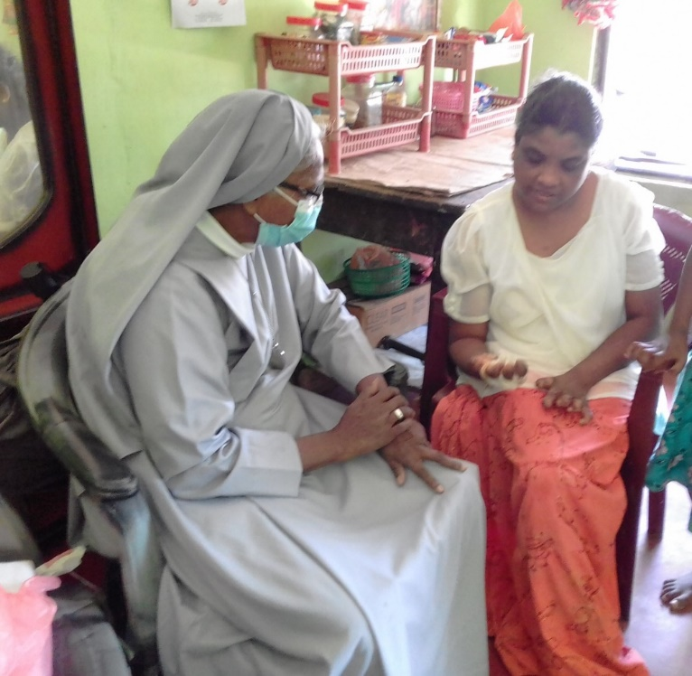
Sister Lalitha inspecting Shivalingam’s hand, which is also damaged by leprosy.
By kind permission of St Francis Leprosy Guild
“This is such a worthwhile cause” she added. “People with leprosy feel that someone kind loves them, and they feel understood. They are so happy that someone is just there for them.”

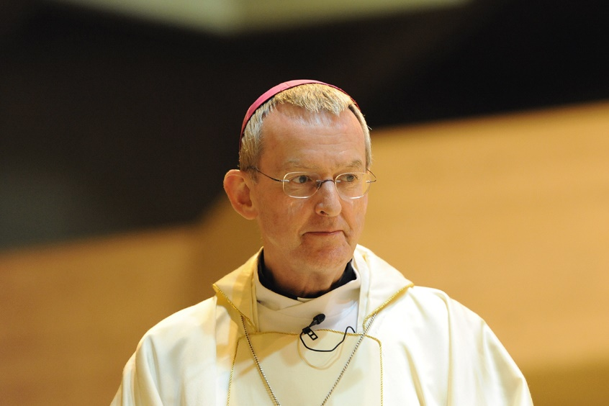
Right Reverend Declan Lang, Bishop of Clifton
By kind permission of cbcew.org,uk
“We are inspired by the work that St Francis Leprosy Guild and the sisters carry out in Sri Lanka, and in other countries across the world” said the Right Reverend Declan Lang, Bishop of Clifton and Chair of the Department of International Affairs in the Catholic Bishops' Conference of England and Wales. “In the communities that you support, there must be great loneliness and hardship. I know that the visits and care you provide have a transformative impact on people’s lives.”
“The Church has a long tradition of supporting our brothers and sisters living with the effects of leprosy. We have a duty to see that they are included and valued.”
“I am mindful of Pope Francis' call to world leaders last World Leprosy Day, to ensure that people are cured from leprosy and can thrive in their communities. I too hope that the leaders of nations will unite in their efforts to treat those with leprosy and promote their social inclusion.”
“I share the Holy Father’s encouragement to nuns, health workers, and volunteers committed to this work and hope that Catholics in England and Wales will pray for and support their mission. It is through such kindness and generosity that people with leprosy can receive medication, provisions and assistance in the most difficult circumstances.”
Badulla Leprosy Centre, Badulla
Badulla has existed since 2013 but the Franciscan Missionaries of Mary have been caring for people with leprosy in Sri Lanka for far longer. The FMM sisters play a major role in treating and supporting leprosy patients at the hospital and further afield.
Sri Lanka
Sri Lanka is an island country situated off south-east India. It has a population of over 21 million people and is home to many religions, ethnic groups, and languages. Although 25 years of violence and civil conflict ended in May 2009, the effects of the conflict are still felt today. Sri Lanka also faces environmental challenges due to the ever-present threat of cyclones and flooding.
Recently introduced government policies to protect the environment, prevent farmers from using chemical fertilizers, which results in lower crop yields for some. This issue is further compounded by low exchange rates which means that buying provisions or other necessary items from abroad has become prohibitively expensive. In addition, financial losses caused by a lack of tourism during the Covid-19 pandemic means a lack of revenue to run the country and poverty for many. Sri Lanka is a World Health Organization global priority country for leprosy.
World Leprosy Day
World Leprosy Day is observed every year on the last Sunday of January to increase the public awareness of leprosy. This date was chosen by French humanitarian Raoul Follereau as a tribute to the life of Mahatma Gandhi who had compassion for people afflicted with leprosy. Gandhi was assassinated on 30 January 1948.
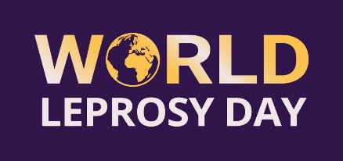
World Leprosy Day logo, by kind permission of ilepfederation.org
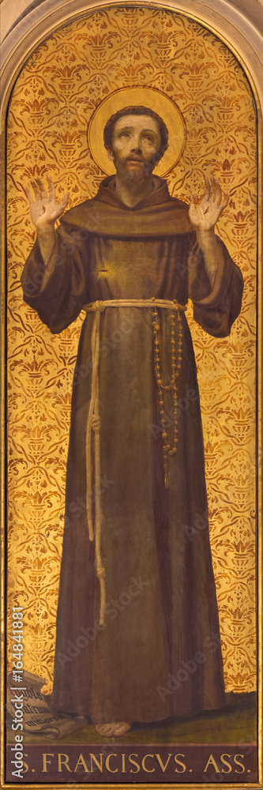
Prayer for people with leprosy from St Francis Leprosy Guild
Lord, we remember the many people around the world afflicted by leprosy.
May we follow the example of your Son, Jesus, and St Francis of Assisi and show them love and compassion.
We pray that they may be freed from the disease and its stigma.
We give thanks for those who have been cured.
We remember those who are permanently marked by the disease and all who care for them.
We give thanks for every Catholic nun who is caring for people with leprosy.
We pray that you will bless them with all that they need to serve those in their care and sustain them in their mission.
Amen.

- END
For other information or interview opportunities please contact:

Clare McIntosh
Chief Executive Officer, St Francis Leprosy Guild, London W10 6EJ, UK
Tel: +44 (0)7754 592240
Email: enquiries@stfrancisleprosy.org
Facebook
http://www.stfrancisleprosy.org
About SFLG
St Francis Leprosy Guild (SFLG) is a UK-based, Catholic charity that is working towards a -leprosy-free world. It supports the work of over 40 leprosy centres, clinics, hospitals, care homes and leprosy-related projects. It works in 15 countries in Africa​, Asia and South America where leprosy is endemic.
About leprosy
1. What is leprosy?
Leprosy (also known as Hansen’s disease) is a complex, chronic neglected tropical disease caused by the Mycobacterium leprae bacterium. It affects the skin, the upper respiratory tract and peripheral nerves in the hands and feet, and the eyes. Leprosy can affect anyone, at any age, but it is linked to poverty, malnutrition, and genetic susceptibility. Leprosy remains an important health problem in low and middle-income countries worldwide.
2. How is leprosy transmitted?
It is thought that leprosy is transmitted via droplets from the nose combined with prolonged, close contact with infected individuals.
3. How is leprosy diagnosed?
Leprosy is difficult to diagnose at its early stages, but it often presents as numb patches on the skin. Currently, the most reliable method to diagnose leprosy, is a slit-skin-smear test in the laboratory.
Leprosy may incubate for up to twenty years before presenting with any signs. If leprosy remains undiagnosed like this, the person affected may unknowingly transmit the disease throughout a community. However, within a short period of receiving multidrug therapy, a person affected by leprosy will no longer be infectious. If leprosy is diagnosed in its early stages, it can be treated readily, and it will not cause disabilities. Preventing disabilities from developing means people with leprosy are less likely to suffer from the stigma and discrimination that can destroy their livelihoods and entire lives.
4. How infectious is leprosy?
95% of most populations have a natural immunity to leprosy. The remaining 5% become vulnerable, mainly through poor nutrition, poor living conditions, lack of hygiene and a weakened immune system. Leprosy is not hereditary.
5. Why are people with leprosy often so disfigured?
People with leprosy lose all feeling in the affected areas and as a result, there is diminished awareness of harm from trauma or heat. Without treatment, the lack of sensation can lead to permanent damage to skin, nerves, limbs, and eyes. It can also lead to the development of recurring, lifelong, hard-to- treat ulcers.
6. Is there a cure? How is leprosy treated?
Leprosy can be cured using Multidrug Therapy (MDT), available at no cost to patients from the World Health Organization. If MDT is taken in the early stages of the disease, permanent damage to nerves is completely avoided.
7. How many are affected by leprosy in the world today?
In recent years, WHO statistics reveal that around 200,000 people are newly diagnosed with leprosy. The Covid-19 pandemic has had a significant impact on health services and leprosy programmes have been affected with a wide disruption to services in many countries. Of great concern is that people with leprosy may receive a late diagnosis and develop lifechanging, visible disabilities as a result. Next years WHO Weekly Epidemiological Record may reveal the hidden truth.
These statistics do not account for those people who have leprosy but who are not diagnosed and are unwittingly transmitting it to their communities. In addition, the statistics do not include those individuals who have been treated for leprosy, but whose disabilities, caused by leprosy need ongoing healthcare needs, or those who are subject to leprosy stigma and discrimination.
8. Which countries have leprosy, where is leprosy endemic?
*The WHO has identified 23 global priority countries for leprosy, where over 95% of the global total of people detected with leprosy are found. The 23 countries are: Angola, Bangladesh, Brazil, Comoros, Cote Ivoire, DR Congo, Egypt, Ethiopia, India, Indonesia, Kiribati, Madagascar, Micronesia, Mozambique, Myanmar, Nepal, Nigeria, Philippines, South Sudan, Sri Lanka, Sudan, Somalia and Tanzania.
*WHO Weekly Epidemiological Record, Global Leprosy Update 10 September 2021, 36, 2021, 96, 421-444 http://www.who.int/wer

