Shivalingam
Shivalingam is 43 years old and lives at home with her mother, in a village outside Badulla, Uva Province, Sri Lanka.
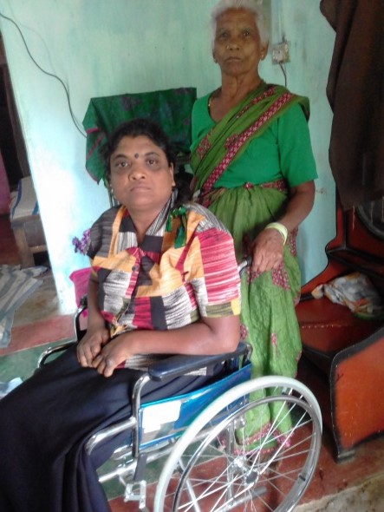
Copyright: St Francis Leprosy Guild

She was just a normal 12-year-old schoolgirl, when she developed cracks and wounds in her toes. After a year of medical treatment, when there was no improvement in the wounds, she was referred to a doctor at the hospital at Badulla Leprosy Centre, who diagnosed leprosy.

She said it made her and her parents very sad. “I feared that I would lose my legs and my dreams would be shattered. During my treatment my family members believed that someone had done a charm to our family.”
During Shivalingam’s treatment, her parents and the FMM sisters visited regularly. They took her to several places to try and cure her wounds, including to India for three months. Sadly, she developed deep wounds in her feet, and eventually had her legs amputated. Badulla provided her with artificial legs.
The FMM sisters will support Shivalingam throughout her life, with medicine, food and emotional support, for example, when she lost her father and brother. Since then, her mother, who is herself sick, has been helping her. The Sisters give her and her mother daily expenses and helped her start a very small boutique in her house. They made a concrete path from the house to the road and built a bathroom inside the house with running water.
​Shivalingam says, “without the support of this centre, I would have found it difficult to manage my basic needs. Without my legs, I am totally depending on the help you give me. Because of the love and concern of the Sisters, we feel that we are not alone.”
​She said, “leprosy is curable. If someone gets this sickness he or she must go to a doctor and take the course of medicine faithfully. Now the medicine is available for this sickness.”
January 2022

