Our silent heroes
It is amazing to think that throughout the world, working in remote or impoverished locations, Catholic nuns, with hearts of compassion and dedication, are caring for people with leprosy, visiting those that are alone or isolated and restoring dignity.
The best-known Catholic nun in recent times, is probably Saint Teresa of Calcutta, founder of the Order of Missionaries of Charity and much-loved confidante of Diana, Princess of Wales. She said, “It is not about how much you do, but how much love you put into what you do that counts.”
St Mother Teresa, Vau I Dejes
But most Catholic nuns are not in the public eye, and it is right that we offer up our thanks, appreciation and prayers for those dedicated Sisters who commit their lives to nursing the sick and in the service of others.
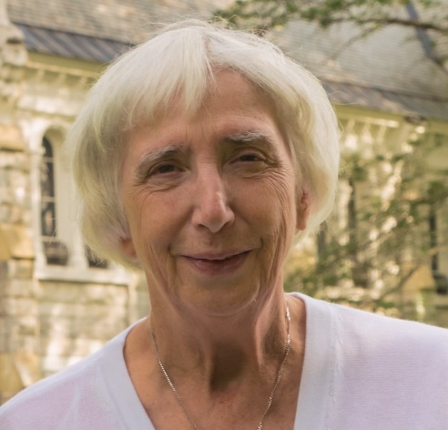
“Effective, compassionate, Christian care is hard to beat,” said Dr Gosia Brykczyńska, RN/RSCN, European President of The International Association of Catholic Nurses (SICIAMS) and Trustee of St Francis Leprosy Guild.

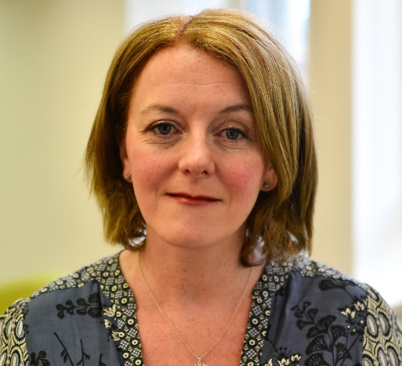
Throughout its history, the UK charity, St Francis Leprosy Guild, has worked with Catholic Orders: missionary nuns who devote their careers and lives to nursing people affected by leprosy.
“It is impossible to quantify how much our dedicated Catholic nuns have transformed lives, caring for people with leprosy and leprosy stigma. Their legacy of love and care is immeasurable and, thank heavens, continues unceasingly. We feel privileged to support the great work of these silent heroes” the St Francis’ Chief Executive Officer, Clare McIntosh.

Sister Lalitha Fernando of the Franciscan Missionaries of Mary works with leprosy patients from the Badulla Leprosy Centre, situated in the lower central hills of Sri Lanka. Her work includes long journeys and travelling to remote locations. She visits people with leprosy as their friend, so their neighbours don’t suspect a link with leprosy, and the stigma and rejection, so often associated with this disease, can be avoided.
Sister Lalitha after a long journey by auto rickshaw
“No matter how long my journey or how tired I feel, I love doing the work of St Francis” said Sister Lalitha who visits around 22 people with leprosy every month. Some are frail and elderly, others are isolated and alone and some are living with lifelong disabilities due to leprosy.
Sister Lalitha is aware that people with leprosy suffer from weakened immune systems and are susceptible to disease and injury and especially, to developing leprosy-related ulcers. So, she takes medication on her visits as well as provisions, such as milk powder and nutritional supplements to top up their daily rations.
People with leprosy live in considerable hardship, even if their community is unaware that they are affected by leprosy. They are grateful for anything she can give them. But Sister Lalitha, gives something more valuable even than provisions. People with leprosy can share their fears and sorrows with her in confidence. In her, they find someone who will listen and care.
“I visit a 40-year-old woman, whose legs are amputated due to leprosy and who is cared for by her 60-year-old mother. I take them provisions and nutritional supplements. When I first met them, their house was dilapidated, and the roof was falling in. We have since replaced the ceiling, provided running water and a toilet thanks to the support of St Francis Leprosy Guild. This is a such worthwhile cause she added. “People with leprosy feel that someone kind, like you, loves them, and they feel understood. They are so happy that someone is just there for them.”
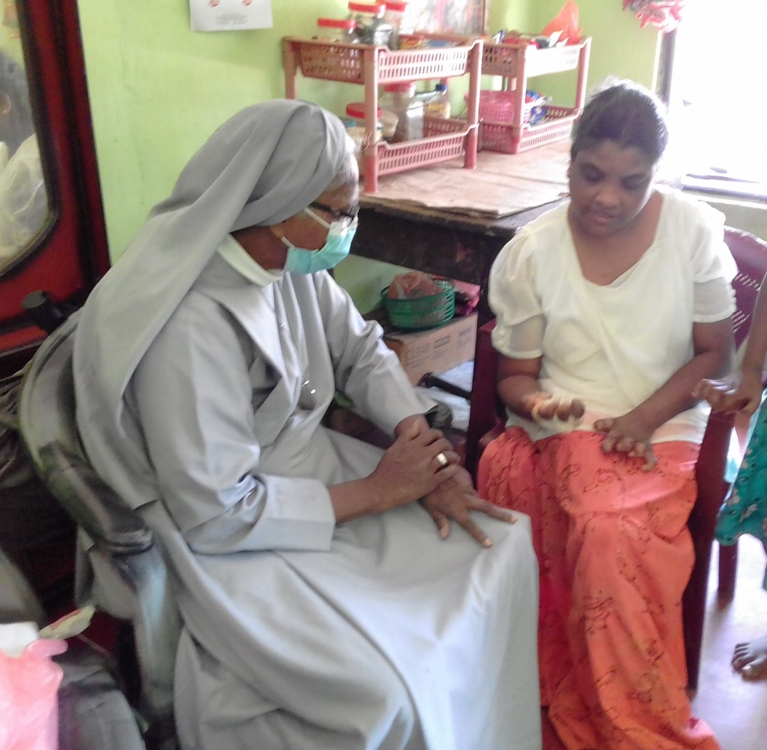
Sister Lalitha visiting double-amputee, Shivalingam, whose hands are also clawed due to leprosy
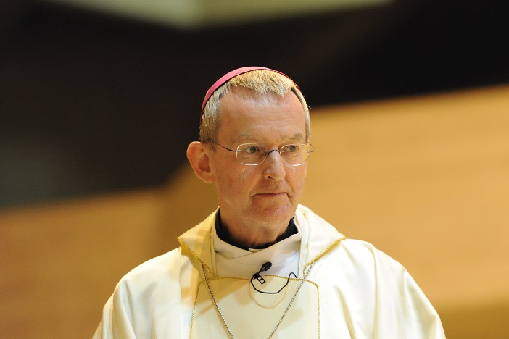
In addition to their patron, Cardinal Vincent Nichols, St Francis Leprosy Guild is fortunate to have the support of the Right Reverend Bishop Declan Lang, Bishop of Clifton and Chairman of the Department of International Affairs in the Catholic Bishops' Conference of England and Wales. He has offered to lend his voice to SFLG’s goal of raising awareness of leprosy within the Catholic church this year.
“We are inspired by the work that St Francis Leprosy Guild and the sisters carry out in Sri Lanka, and in other countries across the world” said the Right Reverend Declan Lang, Bishop of Clifton and Chair of the Department of International Affairs in the Catholic Bishops' Conference of England and Wales. “In the communities that you support, there must be great loneliness and hardship. I know that the visits and care you provide have a transformative impact on people’s lives.”
“The Church has a long tradition of supporting our brothers and sisters living with the effects of leprosy. We have a duty to see that they are included and valued.”
“I am mindful of Pope Francis' call to world leaders last World Leprosy Day, to ensure that people are cured from leprosy and can thrive in their communities. I too hope that the leaders of nations will unite in their efforts to treat those with leprosy and promote their social inclusion.”
“I share the Holy Father’s encouragement to nuns, health workers, and volunteers committed to this work and hope that Catholics in England and Wales will pray for and support their mission. It is through such kindness and generosity that people with leprosy can receive medication, provisions and assistance in the most difficult circumstances.”

On World Leprosy Day 2022, Francis Leprosy Guild asks the Catholic community to reflect on the great work carried out by Catholic Orders of nuns and to unite in prayer for God’s blessing on their vocation.
Prayer for people with leprosy and the nuns that care for them
Lord, we remember the many people around the world afflicted by leprosy.
May we follow the example of your Son, Jesus, and St Francis of Assisi and show them love and compassion.
We pray that they may be freed from the disease and its stigma.
We give thanks for those who have been cured.
We remember those who are permanently marked by the disease and all who care for them.
We give thanks for every Catholic nun who is caring for people with leprosy. We pray that you will bless them with everything that they need to serve those in their care and sustain them in their mission.
Amen.

World Leprosy Day
World Leprosy Day is observed on the last Sunday of January every year to raise the awareness of leprosy. This date was chosen by the French humanitarian, Raoul Follereau, as a tribute to the life of Mahatma Gandhi who had great compassion for people with leprosy. Gandhi was assassinated on 30 January 1948.

Leprosy
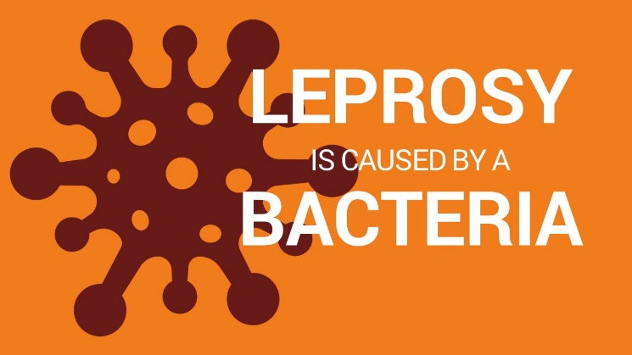
Leprosy, which is also known as Hansen’s disease, is a complex, chronic neglected tropical disease caused by a bacterium, Mycobacterium leprae. Leprosy can affect anyone, at any age but 95% of most populations have natural immunity. The remaining 5% become vulnerable, mainly through poor nutrition and living conditions, a lack of clean water and sanitation and a weakened immune system. Leprosy is not hereditary, but it is a health problem in low and middle-income countries worldwide.

Leprosy affects the skin, the upper respiratory tract and peripheral nerves in the hands and feet, and the eyes. People with leprosy lose all feeling in the affected areas and as a result, there is diminished awareness of harm from trauma or heat. Without treatment, the lack of sensation can lead to permanent damage to skin, nerves, limbs, and eyes. It can also lead to the development of recurring, lifelong, hard-to-treat ulcers.
It is thought that leprosy is transmitted via droplets from the respiratory tract combined with prolonged, close contact with infected individuals. It is difficult to diagnose at its early stages, but it often appears as numb patches on the skin. Currently, the most reliable method to diagnose leprosy, is a skin biopsy in a laboratory. Incredibly, the disease may incubate for up to twenty years before showing any signs. If leprosy remains undiagnosed, the person affected may unwillingly spread the disease throughout their community.
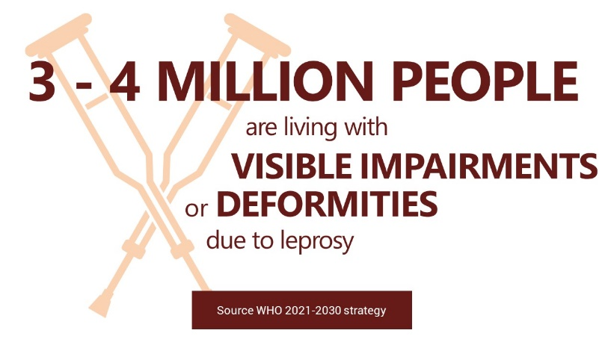
The good news is that there is a readily available treatment for leprosy. Known as Multidrug Therapy or MDT, it is a combination of antibiotics. Soon after receiving MDT, a person with the disease will no longer be infectious. If leprosy is diagnosed in its early stages, it can be treated and cured, and it will not cause disabilities. Preventing disabilities from developing, means people with leprosy are less likely to be subject to the stigma and discrimination that destroys lives. Even today, people affected by leprosy are subject to stigma and discrimination.
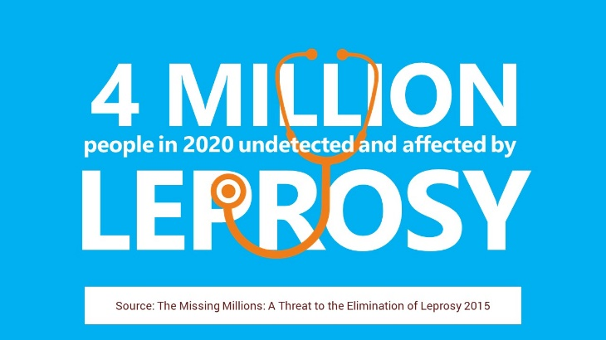
In recent years, statistics from the World Health Organization (WHO) show that around 200,000 people are newly diagnosed with leprosy every year. These statistics do not account for those people who are not diagnosed and are unwittingly transmitting the disease into their communities. In addition, the statistics do not include those individuals who have been treated for leprosy, but whose disabilities, caused by leprosy need ongoing healthcare needs, or those who are subject to leprosy stigma and discrimination. It is estimated that around four million people worldwide are affected by leprosy.
127 countries worldwide reported leprosy to the World Health Organization 2021. There are 23 countries where over 95% of the global total of people detected with leprosy are found. The 23 countries are: Angola, Bangladesh, Brazil, Comoros, Cote d’Ivoire, DR Congo, Egypt, Ethiopia, India, Indonesia, Kiribati, Madagascar, Micronesia, Mozambique, Myanmar, Nepal, Nigeria, Philippines, South Sudan, Sri Lanka, Sudan, Somalia, and Tanzania.
Thank you for reading this article. You now know more than most people about this disease and the devastation it brings to people’s lives. The good news is that it can be cured, and with your support, we can see the end of leprosy in our lifetime.
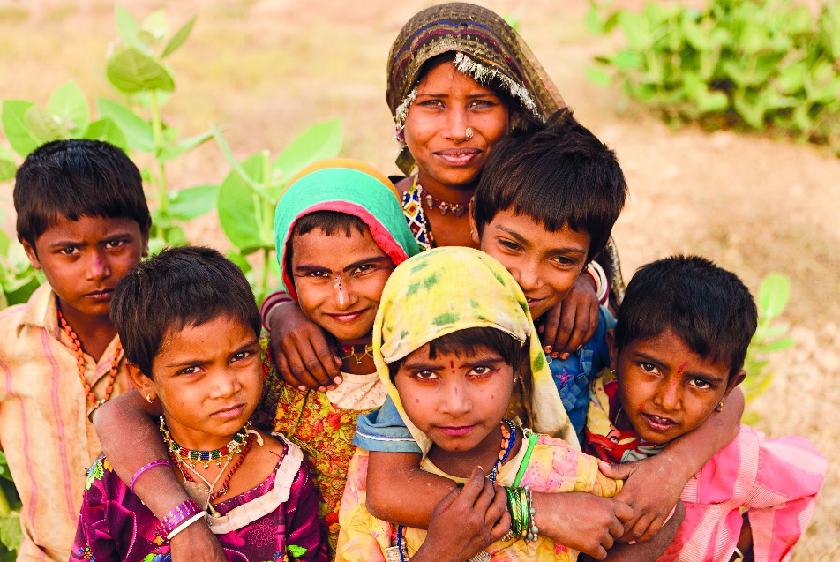
St Francis Leprosy Guild (SFLG) is a UK-based, Catholic charity that is working towards a leprosy-free world. SFLG supports the work of over 40 leprosy centres, clinics, hospitals, care homes and leprosy-related projects. It works in 15 countries worldwide in Africa​, Asia and South America where leprosy is endemic.
For further information please visit:
