LIVING WITH LEPROSY

Why the rest of the world doesn’t suffer from leprosy like India does
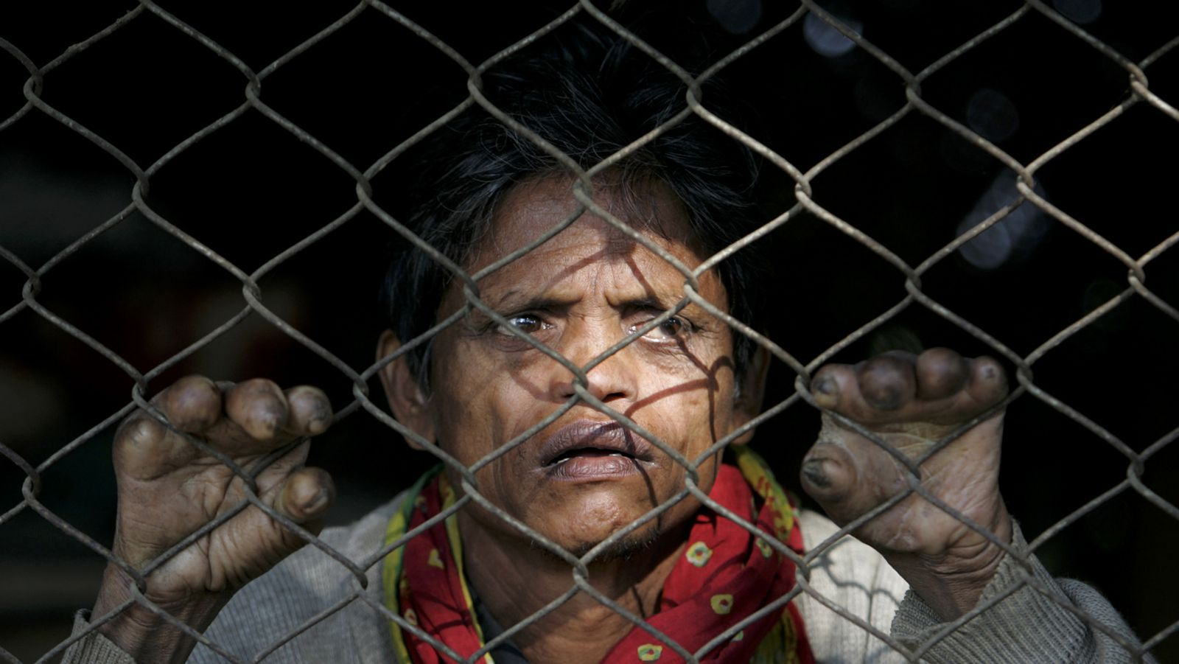

In 2005, the World Health Organisation declared that leprosy had been effectively eradicated worldwide. But this “eradication” only conformed to an arbitrary definition they’d set for themselves a little over a decade before, which meant that its incidence had been driven down to less than a case per 10,000 people.

Skip ahead another 15 years, and 230,000 new cases continue to be detected every year. Of these, India accounts for more than half, about 60%. And although the primary treatment for leprosy—a triple antibiotic course called Multidrug Therapy (MDT)—is provided free of cost by the government, new research suggests that many who suffer from the disease are driven close to financial ruin.

As old as human civilisation
Leprosy is a chronic infectious disease caused by the slow-growing bacterium Mycobacterium leprae, which has afflicted mankind since civilisation itself. It is thought to have originated in East Africa or South Asia in the Late Pleistocene and migrated to India around 2000 BC.

M.leprae, which resembles little fingerprints clustered together under the microscope, gets around through little droplets from the noses and mouths of infected persons. Left untreated, it spreads through the skin and peripheral nerves, damaging the nerves in the hands and feet, causing a loss of sensation and muscle paralysis, particularly at the extremities. The deadening of hands and feet leaves patients prone to the kinds of disabling injuries that have become stigmatising symbols of leprosy.
However, once detected and treated by MDT, in 98% of cases, leprosy ceases to be contagious and can be cured in six to 12 months. If it gets detected too late, though, leprosy can cause nerve damage and conditions such as erythema nodosum leprosum (ENL), a painful immune-mediated reaction causing fever and angry inflammation of the skin, eyes and joints, which calls for powerful steroids or thalidomide, and continuous follow-up visits.

In the kinds of resource-poor regions where leprosy still persists, the cost of a complication like ENL is nothing short of devastating. This is why researchers from the London School of Hygiene and Tropical Medicine, along with clinicians at the Leprosy Mission Trust (LMT) hospital in Purulia district of West Bengal, set out to quantify the direct and indirect costs of leprosy.

50 red-hot lumps
In a series of interviews with 91 patients at the hospital in Purulia, researchers asked them about the direct costs they’d incurred, including paying for medicines, investigation and transport to the hospital, as well as indirect costs covering the loss of a productive family member.

They found that the 53 patients who’d been repeatedly treated for ENL during the past three years had to spend nearly 30% of their monthly household income on treatments, compared to 5% for leprosy patients without it. What’s more, among 38% of patients with ENL, the total cost to the household surpassed 40% of their monthly income.

“Several factors drive up the cost,” said Diana Lockwood from the Department of Clinical Research at the London School of Hygiene and Tropical Medicine, and one of the study’s authors. “Firstly, the condition goes undiagnosed among many patients, so they’ve often been given ineffective medicine. When it was recognised, they’ve been given steroids, (which are not provided free of cost by the government). Also, this problem recurs, so you have this cycle dragging on, of not recognising the problem, travelling time, and being too sick to work.”

Besides which, Lockwood adds, ENL is especially painful, causing “as many as 50 red-hot lumps to appear across the body, making it unbearable for patients to walk or even stand. In the old days, people (who had it) used to commit suicide.”

Can’t fight the stigma
The study doesn’t quantify stigma as an indirect cost, though the authors acknowledge that it has grave impacts, the most damaging of which is a delay in treatment. Long-untreated leprosy damages the nerves in the hands and feet, causing a loss of sensation and muscle paralysis. “Even if (patients) see a few anesthetic patches, they keep them hidden until they start clawing and develop ulcers,” said Joydeepa Darlong, a clinician at the LMT hospital who also worked on the study. “There’s a huge stigma and superstitious beliefs floating around.”

As a result, a lot of patients want total anonymity even if it impacts their treatment. “Some of them don’t want vouchers for free MDT (multi-drug treatment) because they’d have to claim them at a nearby hospital, and then everybody would come to know (they have leprosy),” Darlong adds.

A lot of her patients also refuse to wear micro-cellular rubber footwear that evenly distributes the weight of their feet, which are deadened or “anesthetic” due to chronic nerve damage. If they were to wear regular slippers, the constant pressure on the parts of the sole bearing most of the body’s weight can cause little pressure sores that quickly work their way to the bone. But the shoes, and what they signify, can also get them thrown off a bus or train, make them lose their jobs, or get legally divorced.

Numbers suppressed

The only way to make a dent on leprosy, according to the researchers, is to improve the rate and speed of detection. The latest report from the National Leprosy Elimination Programme (NLEP) claims that leprosy has been eradicated in 33 (pdf) of the country’s states, including Jharkhand and West Bengal, where the study took place.

However, in a report in the British Medical Journal last March, Lockwood pointed out that any fall in prevalence was likely to have come from cutting short the duration of treatment and removing cured patients from the rolls, rather than a reduction in the transmission of the infection.

“The difference between the reported and observed estimates suggests that up to half of India’s leprosy cases are not being reported,” she wrote. The true count of new leprosy cases that cropped up in India between 2013 and 2014 could greatly exceed the NLEP’s count of 127,000 cases.

Lockwood also feared that vociferous talk of eradication gives states an incentive to undercount the new leprosy cases cropping up every year. “India has been reporting about 130,000 new cases a year, which keeps it safely in the eliminated leprosy category. There is, therefore, no incentive to find new cases.

